DES-020 Design Specification

Automate Add Batch Invoice process through RPA

|  |  |
| --- | --- |
| Document Properties |  |
| Author | Sekhar K/Kushal/Akshat |
| Creation Date | 2025/04/23 |
| Last Updated | 2025/06/12 |
| Document Reference | DES-020_Design_Specification |
| Version | 1.0 |

|  |  |
| --- | --- |
| Approvals | Position |
| <Approver 1> |  |
| <Approver 2> |  |

# Document Control

## Change Record

1

|  |  |  |  |
| --- | --- | --- | --- |
| Date | Author | Version | Change Reference |
| 2025/05/02 | Sekhar Kesavarapu | 1.0 |  |
| 2025/06/06 | Sekhar Kesavarapu Kushal Mor Akshat Saxena | 1.2 |  |
| 2025/06/19 | Sekhar Kesavarapu Kushal Mor Akshat Saxena | 1.3 |  |
|  |  |  |  |

## Reviewers

|  |  |
| --- | --- |
| Name | Position |
| William Dale | Director |
|  |  |
|  |  |
|  |  |

## Timeline

|  |  |  |
| --- | --- | --- |
| Task | Start Date | End Date |
| Development | 2025-06-30 | 2025-08-31 |
| Unit Testing |  |  |
| Functional Testing |  |  |
| User testing |  |  |
| Deployment |  |  |

Date Format – YYYY-MM-DD

Contents

1 Document Control 2

1.1 Change Record 2

1.2 Reviewers 2

1.3 Timeline 2

2 Objective 4

2.1 Technical Flow 5

2.2 Assumptions and Dependencies 11

2.3 Software Environment 11

# Objective

Accounts payable invoice automation tools automate the capture, validation, and processing of invoices. These solutions streamline the accounts payable workflow by reducing manual data entry and minimizing errors. It will help to enhance efficiency and ensure timely payment to vendors. Its automatically match invoices to the purchase orders (POs), and non-PO.

We will leverage a Robotic Process Automation (RPA) tool to automate the processing of PO and NON-PO invoices. This involves designing a sequence of activities to execute tasks efficiently and meet the specified requirements.

## Technical Flow



### DOWNLOAD INVOICES FROM OUTLOOK

* There will be a dedicated account where the invoices are expected to be received.
* As soon as the mail is received in the outlook folder (say- “Supplier_Invoice”), RPA flow checks for the unread mail and reads the invoice using activity – Download Outlook Attachment

**Activity name – Download Outlook Attachment**

### EXTRACT iNVOICE DATA

Invoice Header/Lines data would be extracted from the document using a tool called – GenAI.

(GenAI is an artificial intelligence which uses prompt as an input to give the desired output)

Check if PO# exists. If yes, extract Line level details and move to validation. If not, mark it as Non PO and proceed for validation step.

To get the Supplier Number we have 2 options –

1. If PO is present, we can get the Supplier Number through PO number.
2. If PO is not present, GENAI using Supplier Name from the invoice

Using the RPA activity, we can execute the ION API endpoint

**Activity name – ION API Request**

### VALIDATION OF DATA

Validate if all the required mandatory fields are not empty using if/else conditions activities and check if extraction confidence is>=95% in RPA.

Fields are –

* Supplier Name
* Supplier Invoice Number
* Invoice Date
* PO Number (if applicable)
* Line items
* Total amount
* Currency
* Tax Code (VTCD)

**Activity name – If**

If the data is valid, we move towards the next steps

If the data is not valid, we push the data into IDM with a status - Invaild

The data is pushed into IDM using an IDM endpoint.

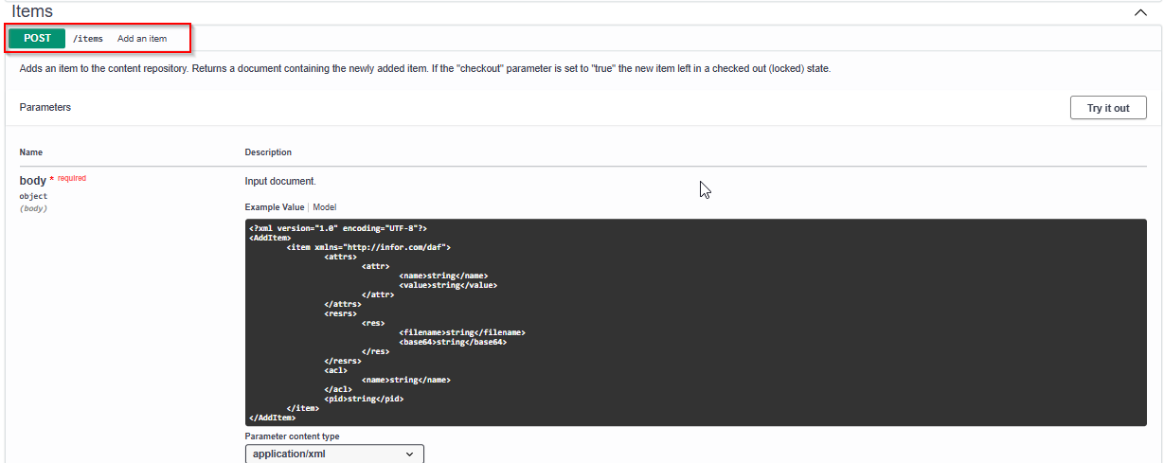

Using the above activity ION API Request, we can push the document into IDM.

### SENd the INVOICE TO IDM

Upon successful validation of all mandatory fields, confirm the status of the document based on the below extraction conditions.

* **Ready – Status id - 90**→ all fields present and high-confidence (>=95%)
* **Requires Review – Status id - 20** → incomplete or low-confidence
* **Invalid – Status id -** **10** → corrupted or unreadable file

The document is pushed into IDM with the above status as an attribute using the below IDM endpoint.

### AP Clerk REVIEW



### PUSH invoice data using M3 endpoint

Create an RPA bot which checks the IDM for every 5 mins if any Invoice available with status ready. For each available document, push the invoice into M3 using endpoint - APS450MI.AddHead to create Header information and APS450MI.AddLine for Line details.

Create invoice in M3 through APS450MI.AddHead

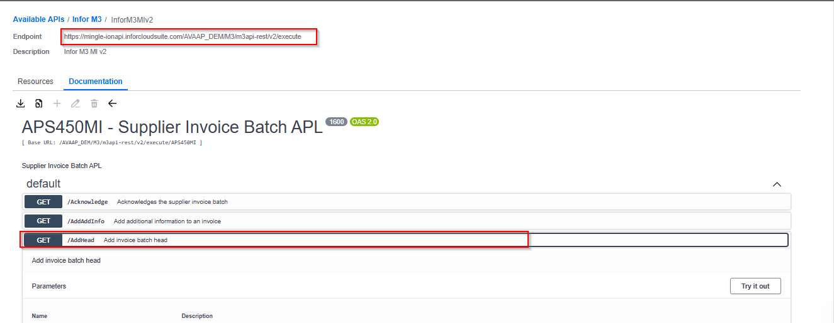

The above end point is called using the activity name – ION API Request.

### Input to the APS450MI.AddHEAD

|  |  |  |  |
| --- | --- | --- | --- |
| **Name** | **Description** | **Mandatory Input** | **Output** |
| DIVI | Division | M | Invoice Batch Number |
| IBTP | Invoice batch type |  |  |
| SINO | Supplier invoice number | M |  |
| SPYN | Payee | M |  |
| SUNO | Supplier | M |  |
| IVDT | Invoice date | M |  |
| CUCD | Currency | M |  |
| ARAT | Exchange rate | M |  |
| TEPY | Payment terms | M |  |
| PYME | Payment method - accounts payable | M |  |
| TDCD | Trade code | M |  |
| CUAM | Foreign currency amount | M |  |
| VTAM | VAT |  |  |
| ACDT | Accounting date |  |  |
| APCD | Authorized user |  |  |
| IMCD | Invoice matching |  |  |
| SERS | Service code |  |  |
| DUDT | Due date |  |  |
| FECN | Future rate agreement number |  |  |
| CRTP | Exchange rate type | M |  |

### Error Handling Enhancements

If API execution in section 2.1.5 fails, add this document to the exception queue where alerts will be triggered to the concerned team with error details.

In order to achieve this, make an entry in CUGEX1 table with Invoice & error details.

An ION workflow would be triggered upon entry in CUGEX1 table which helps triggering notification to the AP team.

### SLA Monitoring and Escalation

Create a workflow to monitor the status of the Invoice documents in IDM which requires attention of AP team.

Check if resolution time exceeds 4 hours and sends an alert to the AP team.

Escalate to AP Manager if unresolved after **8 hours**

## Assumptions and Dependencies

PO data exists in M3 for PO invoices.

File type should be .pdf and .png

The invoice should not be handwritten.

The invoices should be at least 300 DPI.

## Software Environment

Environnent - https://mingle-portal.inforcloudsuite.com/v2/AVAAP_DEM/

RPA – 2025-05-rel-1-0-5

IDM – 2025.05.02-01

M3 – 1.0.0.20250318-091026_02